ANIMAL CARE AND USE PROGRAM EMERGENCY PHONE CONTACTS
IN CASE OF… | CALL… | AT…
1. Mechanical malfunctions… | Physical Plant Administrative Office | 662-915-7051
2. Heating and cooling emergencies… | Call the following in this order:
2. Heating and cooling emergencies… | 1. Associate Utility Engineer | 662-915-7051
2. Heating and cooling emergencies… | 2. Assistant Superintendent of Mechanical Services | 662-915-5909
2. Heating and cooling emergencies… | 3. HVAC Shop Supervisor | 662-915-5909
3. After hours or holiday emergencies… | Physical Plant Maintenance 24/7 answering service. They will contact on-call personnel. | 662-915-7087
4. Natural disasters, e.g., flood, hurricane, earthquake, tornado, or an accident… | Follow the procedures detailed in the Emergency and Disaster Plan for Animal Facilities at the University of Mississippi, Oxford Campus. | *See numbers below
5. Fire… | Fire Department | *See numbers below
6. Non-emergency Fire Code issues… | University Fire Inspectors | 662-915-2132
7. Security emergencies… | UPD | *See numbers below
8. Accidents… | Ambulance | *See numbers below
9. Hazardous material spills… | Hazardous Materials Response Team | 662-915-5433
10. Animal illnesses or other problems…  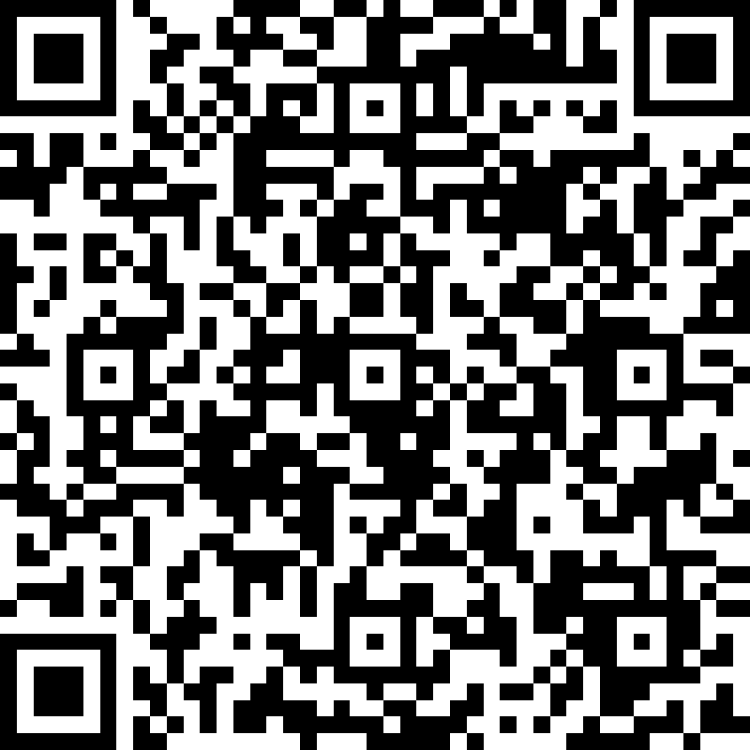  Anonymously report an animal welfare concern: | Vet-on-Call (Dr. Harry Fyke) | 662-915-5324 (o)  662-234-2928 (clinic)  662-801-4327 (cell)  hfyke@olemiss.edu
 | Emergency Vet (Dr. Ware Sullivan) | 662-234-8538 (clinic)  662-801-7657 (cell)  waresull@gmail.com
11. Animal facility problems… | ORSP front desk | 662-915-7482
11. Animal facility problems… | Animal Care Supervisor (Penni Bolton) | 662-915-5324 (o)  662-481-2801 (text) pboltonl@olemiss.edu
11. Animal facility problems… | Vet-on-Call (Dr. Harry Fyke) | 662-915-5324 (o)  662-234-2928 (clinic)  662-801-4327 (cell)  hfyke@olemiss.edu
12. Animal rights activist & media inquiries… | Call the following in this order:
12. Animal rights activist & media inquiries… | 1. Director of University Marketing and Communications (Jim Zook) | 662-915-2138 (o)  jzook@olemiss.edu
12. Animal rights activist & media inquiries… | 2. Attending Veterinarian (Dr. Harry Fyke) | 662-915-5324 (o)  662-234-2928 (clinic)  662-801-4327 (cell)  hfyke@olemiss.edu
12. Animal rights activist & media inquiries… | 3. Vice Chancellor for Research and Sponsored Programs (Dr. Josh Gladden) | 662-915-7583 (o)  662-701-8792 (cell)  jgladden@olemiss.edu
12. Animal rights activist & media inquiries… | 4. Director of Research Integrity and Compliance (Mandy King) | 662-915-5458 (o)  618-713-1744 (cell)  mlking9@olemiss.edu
13. Animal rights activist harassment or threats... | UPD | *See numbers below
*FROM AN ON-CAMPUS PHONE:  for emergencies dial 9-911 | *FROM AN OFF-CAMPUS PHONE OR CELL PHONE: for emergencies dial 662-915-4911 | *FOR ALL NON-EMERGENCIES: dial 662-915-7234
University Weather and Other Emergency News Hotline: 915-1040 |  | Mississippi Road Conditions & Weather: 1-888-728-4218

