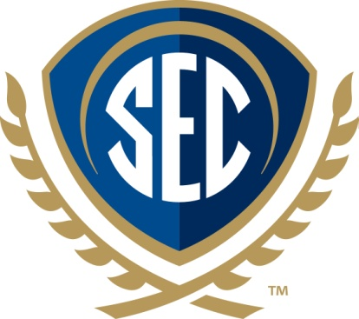

SEC Academic Conference Calendar Listing Information

Who: Southeastern Conference (SEC)

What: 2017 SEC Academic Conference entitled The Future of Water: Regional Collaboration on Shared Climate, Coastlines, and Watersheds

When: March 27-28, 2017

Where: The Mill Conference Center on the campus of Mississippi State University in Starkville, Mississippi.

Why: The SEC Academic Conference is designed to showcase SEC faculty and student research in an area of significant scholarly interest to a range of academic, legislative and other stakeholders. This event also expands the opportunities for collaboration among the 14 member research universities of the SEC.

How: Increased climate variability and water demand are bringing water issues to the forefront. Drought, declines in aquifers used for irrigation, and sea-level rise are among core topics of interest. The SEC Academic Conference should stimulate communication and collaboration toward sustainable and resilient water resource management in the Southeast, with overarching themes to include shared inland waters and aquifers, coastlines, climate and regional policy.

Stay Connected:
Online – www.TheSECU.com and www.SECConference.msstate.edu
Twitter – @THESECU
Facebook – TheSECU
YouTube – SECUniversity
Instagram – TheSECUniversity

